Linux Commands Practical

***Basic Command***

echo $SHELL

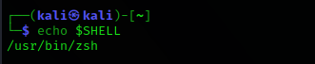

type command

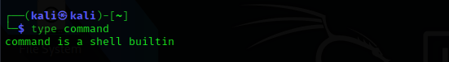

date



date +%D

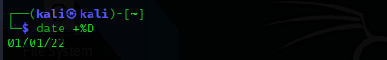

mkdir <file name>

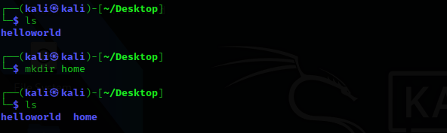

Cal 2022

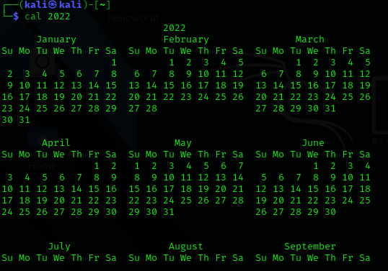

Cat /etc/shells

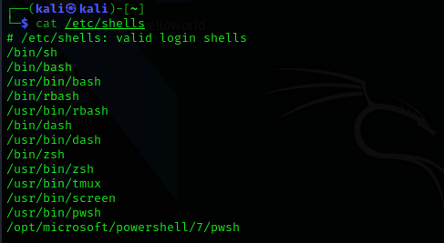

Root access command

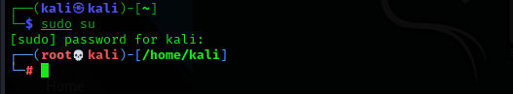

Mkdir < folder name>



Rm -rf < file name to delete>

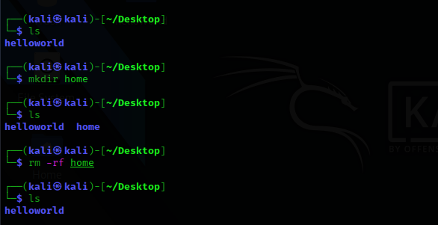

pwd

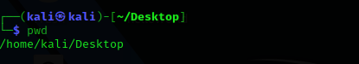

Checking web server connection command – ping <ip address/web>

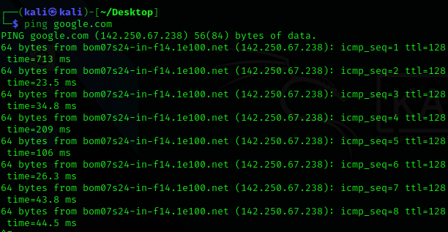

Cat <file name>

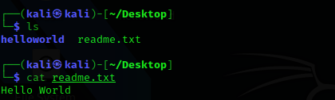

Chmod +x *

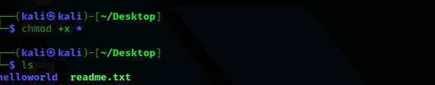

Downloading library files command

